1. Install nginx and run nginx on port number 81.

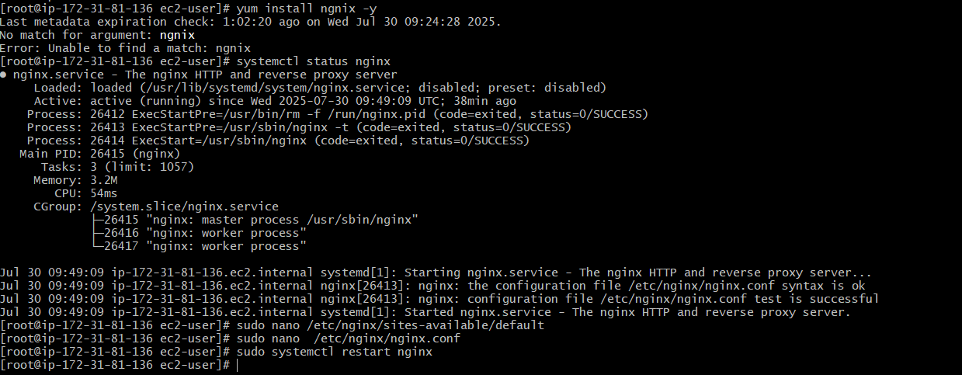

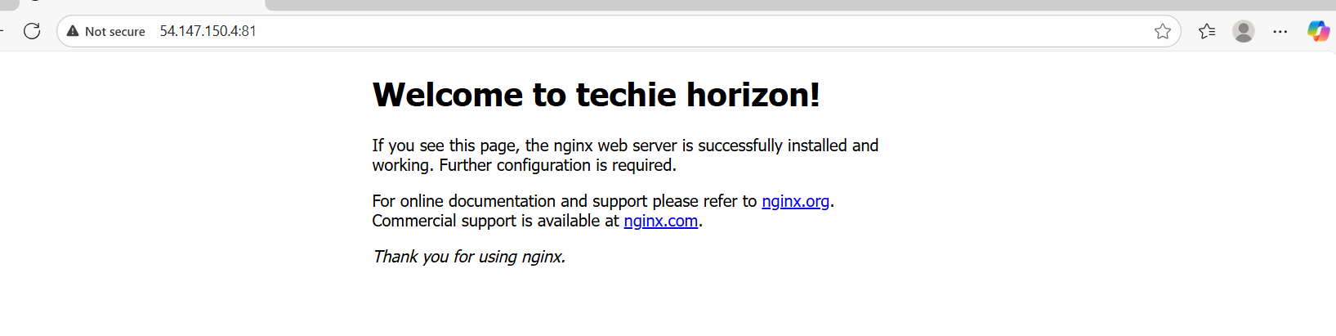

1. Deploy a sample index.html file on nginx.

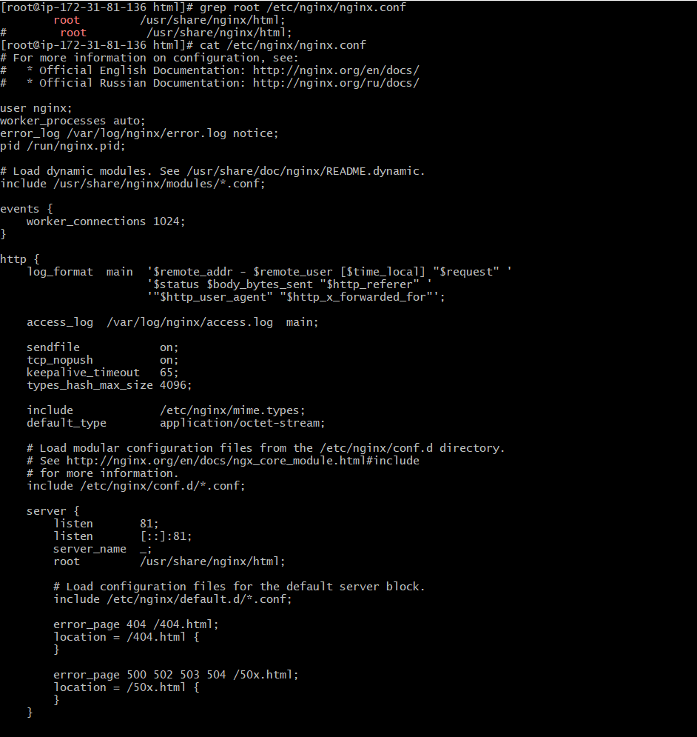

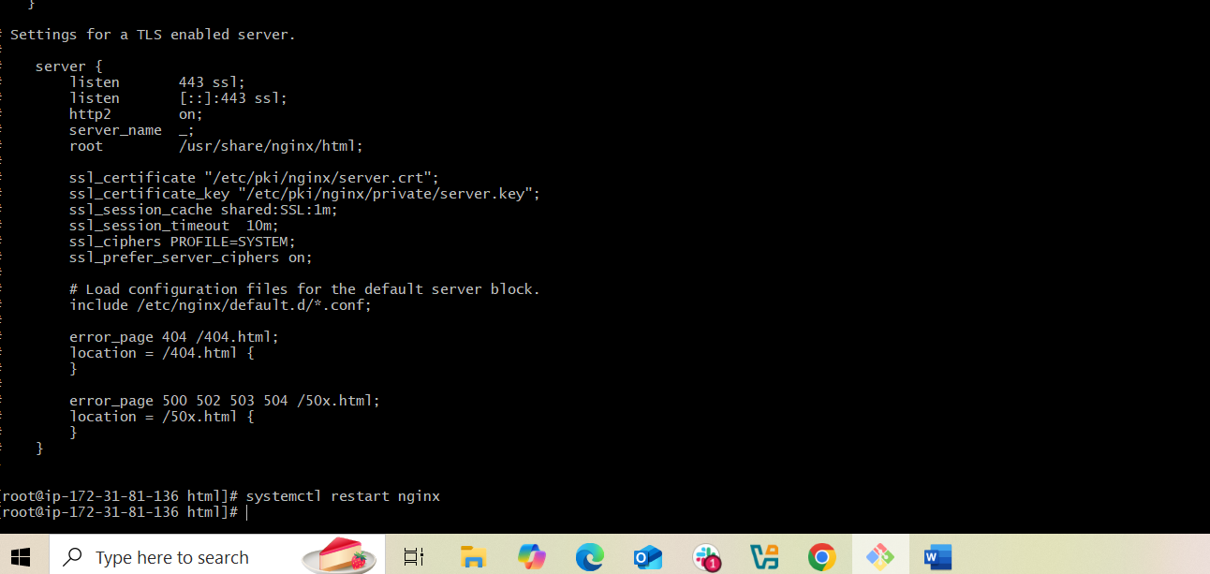



1. Install Apache and run Apache on port number 82.

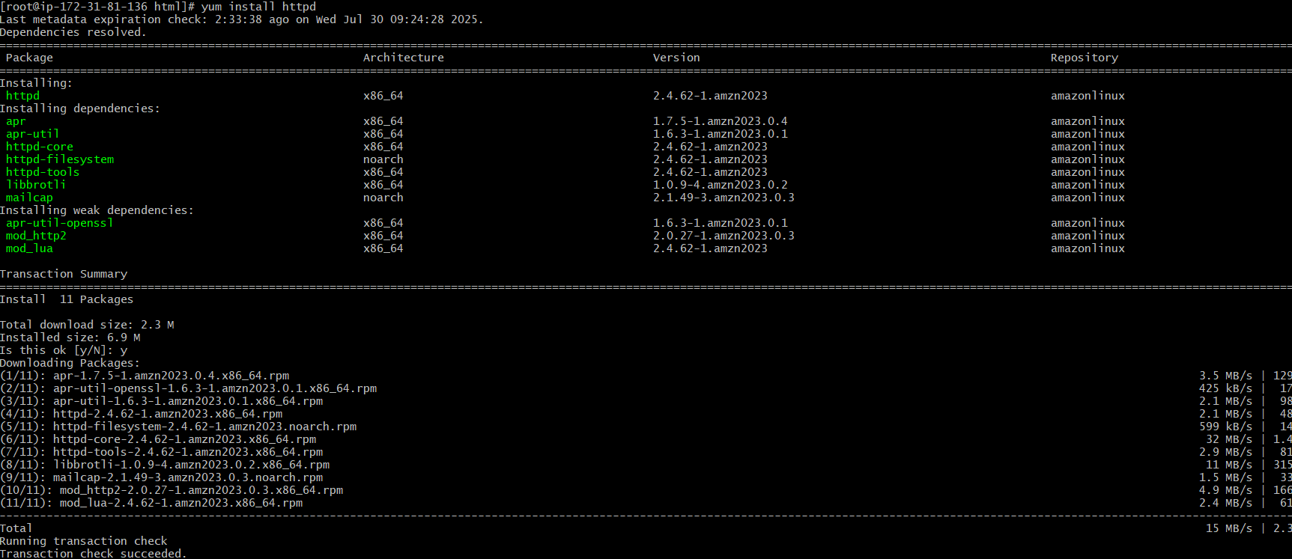

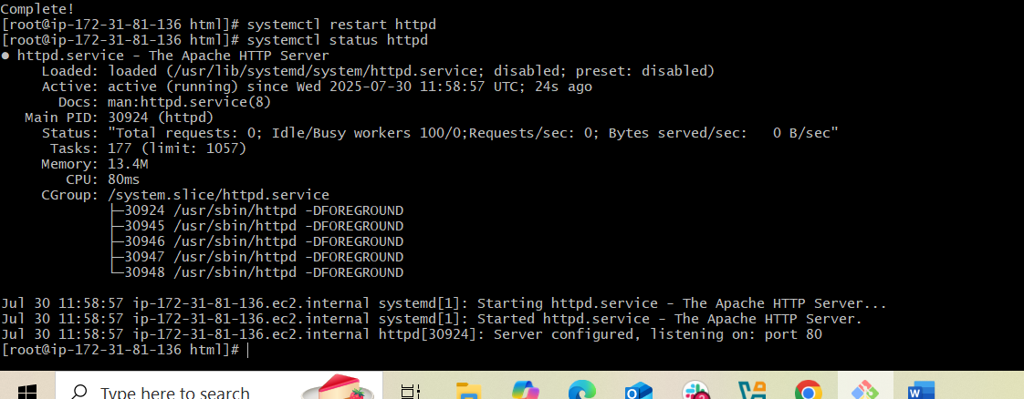

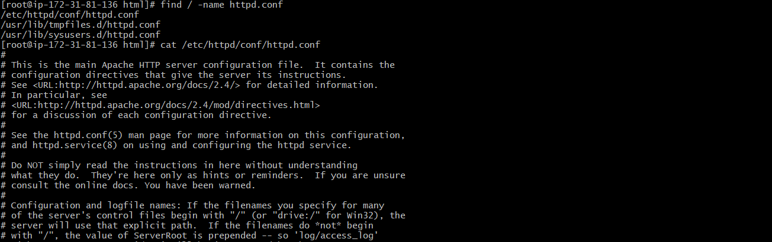

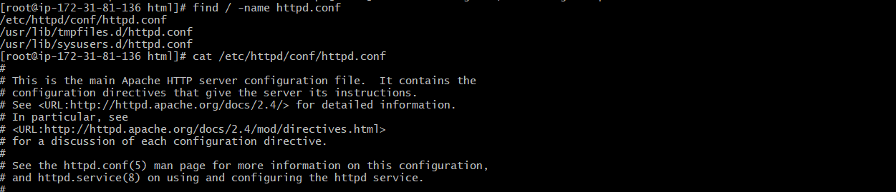

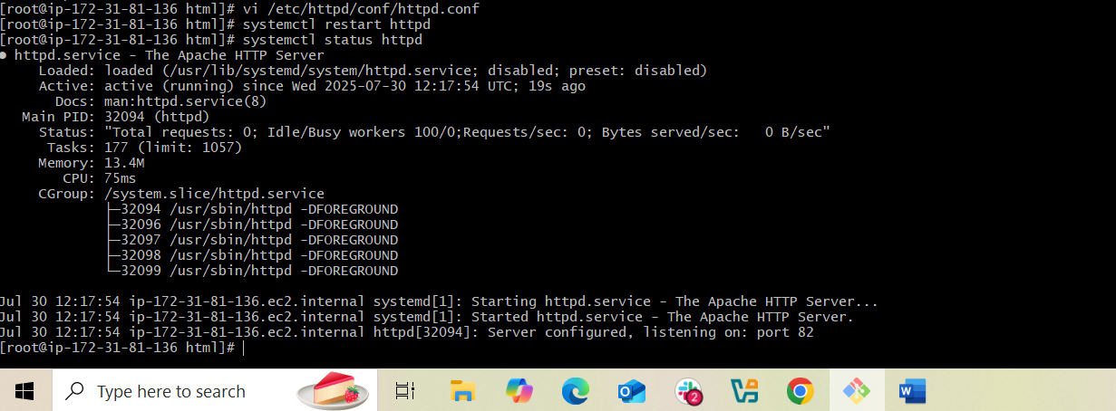



1. Deploy a sample index.html file on apache.

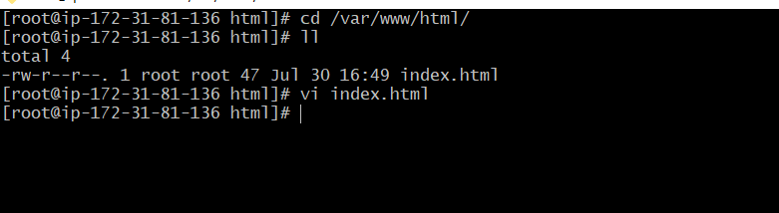



1. Install Apache tomcat on port number 8082.

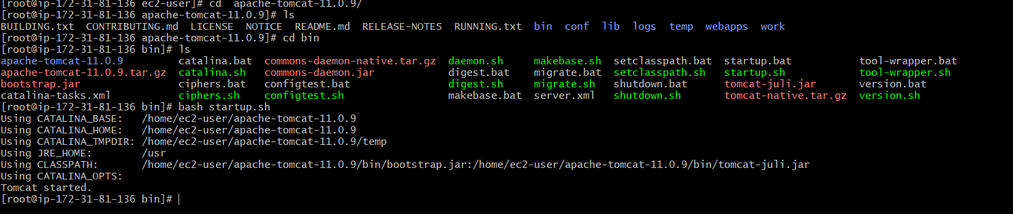

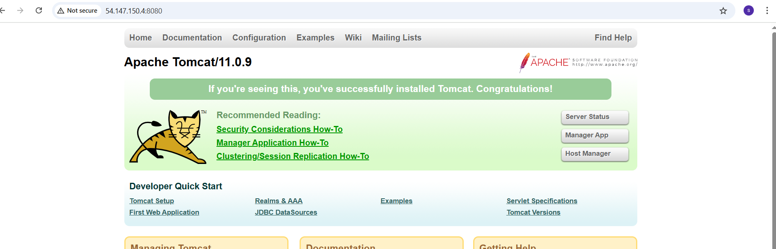



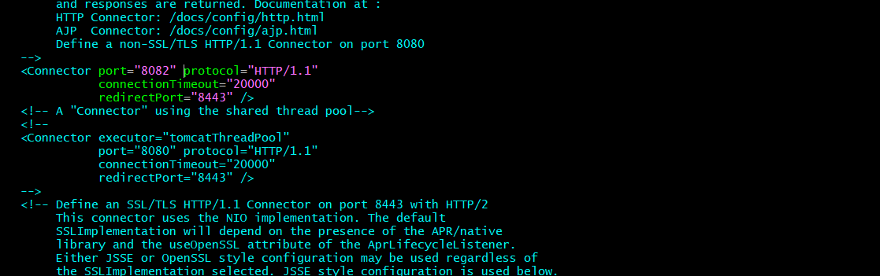

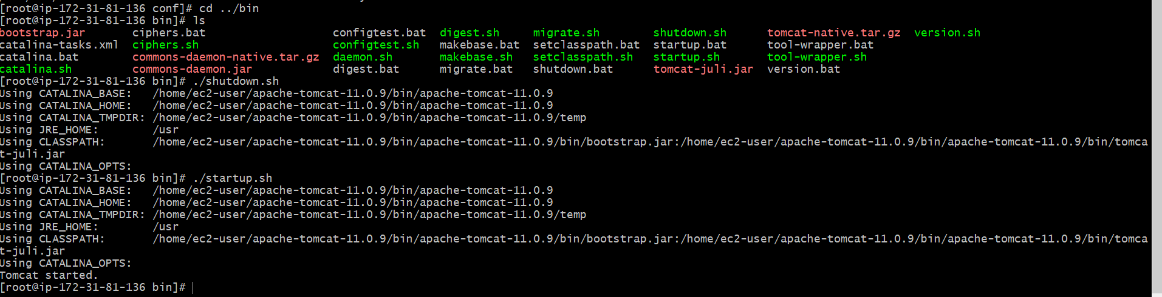

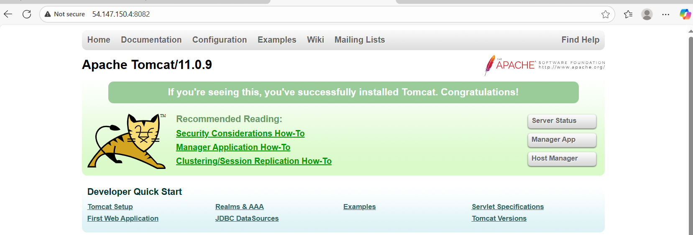

1. Deploy a sample app on webapps.

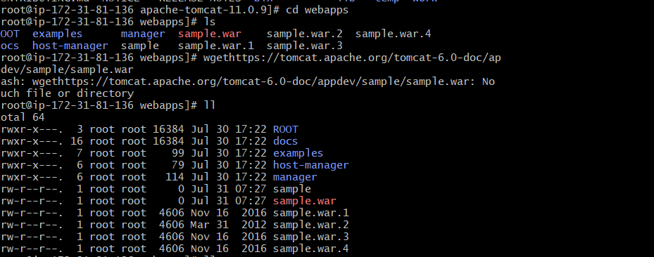

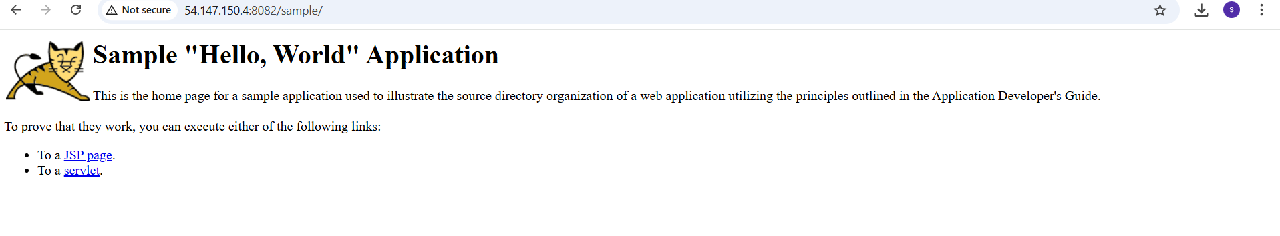

1. Create a tomcat.service file for tomcat.

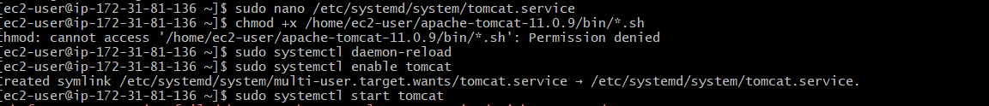

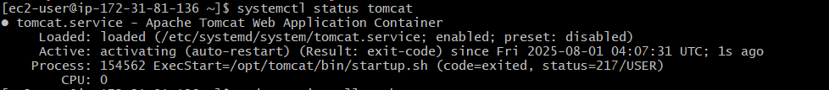

1. Configure HA Proxy server.

